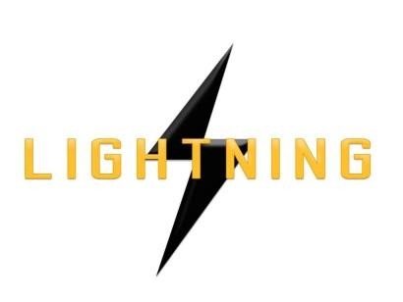

Lightning Ventures Inc.
Suite700-838 W Hastings Street, Vancouver, BC, V6C 0A6

LIGHTNING VENTURES ANNOUNCES LIFTING OF MANAGEMENT CEASE TRADE ORDER

VANCOUVER, CANADA, September 12th, 2017 – Lightning Ventures Inc. (CSE: LVI) (Frankfurt: 1HM) is pleased to announce that it has filed its annual financial statements and management’s discussion and analysis for the year ended March 31, 2017, together with the related certifications, and thus the Management Cease Trade Order imposed by the British Columbia Security Commission on August 1, 2017 was lifted pursuant to National Policy 12-203.

About Lightning Ventures

Lightning Ventures Inc. (CSE: LVI) (Frankfurt: 1HM) is an oil and gas industrial services company. It operates a specialty manufacturing business based in Hobbs, New Mexico through its subsidiary Lightning Industries, Inc., which provides products to enhance efficiency and increase the production of oil and gas wells.
Further information about Lightning Ventures is available under its profile on the SEDAR website www.sedar.com and at www.lightningind.com.
For further information on the Company, please contact:
Donald Rainwater
Chief Executive Officer
Lightning Ventures Inc.
Telephone: 210-535-5700
Email: don@rainwater-investments.com
Neither the Canadian Securities Exchange nor its Market Regulator (as that term is defined in the policies of the
Canadian Securities Exchange) accepts responsibility for the adequacy or accuracy of this release.

